ABSTRACT
Mahalle-Connect: An AI-Powered Hyper-Local Social Network and Event Discovery Platform
This paper introduces a new application called Mahalle-Connect. This application was created as a result of the lack of social connectivity that is being witnessed in urban settings. Although there is widespread digital communication around the world, there has been a reported lack of interaction within local communities. A technological solution was therefore sought to solve this problem.
The proposed project, Mahalle-Connect, has been conceptualized and designed as an interactive mobile application that facilitates links within a particular geographical area, which may range from a neighborhood to an entire district. The application facilitates the spreading of local updates and the representation of local events. The salient factor about this project is the application of Artificial Intelligence for acquiring and processing data. An automatic data acquisition pipeline has been created by utilizing the municipality website, cultural blogs, and local events listings. The Natural Language Processing algorithms are applied for unstructured text analysis for extracting important metadata about the events, such as the date, venue, and category of the events.
In an effort to upgrade the user experience, a recommendation system was also incorporated into the design. Using geolocation, personal interests, and past usage patterns, the system recommends and prioritizes content to overcome information overload.
“The technical infrastructure rests upon established industry standards.” FastAPI frameworks were used for backend services, with PostgreSQL used for managing the database and PostGIS for the management of geospatial data. GeoAlchemy2 is used for managing the geographic data, while the task queues control the data collection operations in the background. Cross-platform frameworks were used for the design of the mobile interface and mapping tools for visualizing data based on proximity.
The outcome framework reflects a holistic integration of concepts from artificial intelligence, data management, and geographic information systems. This platform is expected to help in the development of community links, foster a sense of community, and therefore help in the reduction of social isolation in urban areas.
Keywords: Artificial Intelligence, Hyper-Local Social Network, Natural Language Processing, Recommendation Systems, Geographic Information Systems.

ÖZET
Mahalle-Connect: Yapay Zeka Destekli Hiper-Yerel Sosyal Ağ ve Etkinlik Keşif Platformu
Bu çalışmada, kentsel yaşamda giderek azalan toplumsal bağları ve komşuluk ilişkilerini yeniden güçlendirmeyi amaçlayan Mahalle-Connect uygulaması ele alınmıştır. Küresel ölçekte dijital iletişim olanakları artmış olsa da, bireylerin yakın çevreleri ve yerel mekanlarla olan etkileşiminde bir zayıflama gözlemlenmektedir. Bu bağlamda, teknolojiden yararlanılarak mahalle kültürünün canlandırılması ve yerel etkinliklere erişimin kolaylaştırılması hedeflenmiştir.
Mahalle-Connect, kullanıcıların bulundukları mahalle veya daha geniş bölgelerdeki diğer bireylerle etkileşim kurmasına olanak tanıyan bir mobil platform olarak tasarlanmıştır. Uygulama aracılığıyla yerel güncellemeler paylaşılabilmekte ve bölgedeki etkinlikler takip edilebilmektedir. Projenin ayırt edici özelliği, veri toplama ve anlamlandırma süreçlerinde yapay zeka teknolojilerinin kullanılmasıdır. Belediye web siteleri, kültür-sanat blogları ve yerel etkinlik listelerinden otomatik veri çeken bir sistem geliştirilmiştir. Bu sistemde, metinlerin analizi ve tarih, konum, etkinlik türü gibi kritik verilerin ayrıştırılması için Doğal Dil İşleme (NLP) algoritmalarından yararlanılmıştır.
Kullanıcı deneyimini optimize etmek amacıyla, kişiselleştirilmiş bir öneri sistemi entegre edilmiştir. Kullanıcının konumu, ilgi alanları ve geçmiş uygulama içi etkileşimleri analiz edilerek, bilgi kirliliğinin önüne geçilmesi ve en ilgili içeriklerin sunulması sağlanmıştır.
Sistemin teknik altyapısında endüstri standardı araçlar tercih edilmiştir. Arka uç geliştirmesinde FastAPI, veritabanı yönetiminde PostgreSQL ve mekansal verilerin işlenmesinde PostGIS kullanılmıştır. Coğrafi bilgilerin işlenmesi GeoAlchemy2 ile sağlanmış olup, veri toplama süreçlerinin arka planda yönetilmesi için görev kuyruklarından (task queues) yararlanılmıştır. Harita tabanlı görselleştirmelerin entegre edildiği mobil arayüz, bu teknolojilerle desteklenmiştir.
Sonuç olarak; yapay zeka, veri yönetimi ve coğrafi bilgi sistemlerini birleştiren bütünleşik bir sistem ortaya konulmuştur. Geliştirilen bu platformun, bireylerin yerel topluluklarıyla bağlarını güçlendirmesine ve şehirlerdeki sosyal izolasyonun azaltılmasına katkı sağlaması öngörülmektedir.
Anahtar Kelimeler: Yapay Zeka, Hiper-Yerel Sosyal Ağ, Doğal Dil İşleme, Öneri Sistemleri, Coğrafi Bilgi Sistemleri.

1. INTRODUCTION
Today, social interactions in city life are observed to have been fundamentally changed by rapid urbanization, digitalization, and individualization. In cities that are especially dense, individuals’ relationships with neighborhood and local life are seen as increasingly disconnected; information sharing and community interaction are observed to be becoming less common, and neighborhood relationships are subsumed by digital media. While international forms of communication are offered by existing social networks, sufficient focus is not placed on local needs and hyper-local information flow.
To make communities more social, Mahalle-Connect was created as part of this final project as an AI-powered hyper-local social network and event discovery platform. Making communication with people in their own territory accessible only to those within their geographical boundaries, providing local announcements, and finding occurrences nearby are aimed by the project. Meanwhile, enhancing its effectiveness by providing users with personalized content based on artificial intelligence-based data processing and recommendation systems is sought.
In this section, the general form of the end project, the importance and the problem addressed are described, followed by a description of what is and is not included in the work.

1.1. General Information
Communication between individuals has been improved and made accessible from anywhere on the globe by digital social networks. However, local needs are often avoided by the majority of these networks, and users are directed into a space outside of their immediate environment to engage as visitors in an environment that is disconnected from the surroundings. In recent years, hyper-local platforms have begun to be brought into prominence, particularly when smart city applications and community-based digital solutions are considered.Hyper-local social networks are utilized as means to share information, announcements, and events specific to a particular region based on user location. It is accepted that security in communication, rapid sharing of information, and community awareness at the neighborhood level can be provided by this system.
1.1.1. The Development of Hyper-Local Social Networks
While mobile device use was increased, the creation of hyper-local platforms was driven by the increased availability of location-based services and the rise in mobile device utilization. These systems were initially based solely on maps and location sharing and have been expanded along with social interaction, event sharing, and local announcements in the years since. Today, such systems are actively operated in the areas of smart cities, community management, and boosting local participation.

1.2. Purpose
Developing a location-based, AI-based social networking platform that aims to improve neighborhood and community engagement despite increasing crime in cities is focused on in this final project. The main problem presented in the project is defined as the fact that local events and announcements are scattered across multiple sources and it is not known by users what is happening in their neighborhood or what other social networks fit in with hyper-local needs.
To help solve this problem, a system has been created wherein data is automatically gathered from other sources through web scraping, interpreted via natural language processing, and then personalized content is provided for users. The proposed system is designed to prioritize content that interests users and location information.
1.2.1. Problem Definition and Solution Approach
In the context of the project, however, the problem with presenting the local information flow in a centralized and personal structure is observed. In order to solve this problem, a multilayered and intelligent platform has been proposed, in which artificial intelligence, geographic information systems, and modern web services are utilized.

1.3. Scope
Focus is placed on a mobile-based social networking application design, development, and test in this study. A variety of components, including backend, frontend, database, artificial intelligence-based data processing, and recommendation systems, are included in this project.
1.3.1. Areas Included in the Scope of Work
In the scope of the project, FastAPI is used for the backend architecture. Local data management is handled by PostgreSQL and PostGIS. In the model for automated data collection and analysis, web scraping and natural language processing processes are employed.for automatic processing of event data, and mobile application development processes were addressed.
1.3.1.1. Excluded Topics
Real-time scaled user tests, commercial distribution processes, and the measurement of the platform's long-term sociological effects are excluded from the scope of this study.
2. LITERATURE SURVEY
This section synthesizes existing academic research to establish the theoretical and technical framework of "Mahalle-Connect." The review critically examines three intersecting domains: the sociological effects of vertical urbanization on community cohesion, the comparative performance of spatial database architectures, and recent advancements in Turkish Natural Language Processing (NLP).

2.1. The Sociological Impact of Vertical Architecture

In demographic discourse, urbanization is commonly analyzed. However, its impact on social relationships is also significant. In the context of Turkey, the sudden transformation in high-rise apartment buildings has significantly influenced community relationships. This is explained through the concept of "spontaneous disconnection" (kendiliğinden irtibatsızlık), which is explained through the works of Özarslan (2016). This discussion is in line with the idea that high-rise buildings create physical closeness but induce social aloofness through which common spaces are abolished that are essential for solidarity relationships. This idea is in line with sociological discourses that emphasize the impact of architecture on human relationships.

In contrast to the effects of alienation in the city, the "Smart City" approach has emerged as the remedy. Nonetheless, the strictly technocratic application of the Smart City approach has come into question by Seçkiner Bingöl (2021a). Via systematic reviews, the Smart People approach has emerged, implying that technology should be the platform for active participation, not merely observation. From the idea of livability, the importance of the idea of "walkability" has become key for Özdemir and Çetin (2021), whose studies show that the cultural environment flourishes in areas that can be walked through to access activities and services. These findings have been practically realized by the approach of "Mahalle-Connect," which focuses on the hyper-local and walkable approach in an effort to rebuild the fragmented society created by vertical living.

2.2. Evaluation of Spatial Database Technologies
The efficiency of a location-based platform relies heavily on its underlying data architecture. Extensive benchmarks comparing Relational Database Management Systems (RDBMS) with NoSQL alternatives for geospatial tasks are provided in the academic literature.
In a comprehensive performance analysis, it is demonstrated by Sveen (2019) that for structured, homogeneous spatial data, traditional RDBMS solutions like PostGIS offer superior performance over NoSQL systems. This advantage is attributed to the efficiency of R-Tree indexing mechanisms in handling standard radius-based queries, which are central to the functionality of "Mahalle-Connect."
Furthermore, regarding scalability, a comparative study between PostGIS and distributed frameworks such as GeoSpark is presented by Huang et al. (2017). While it is acknowledged that distributed systems excel in massive-scale spatial joins, findings indicate that for user-centric applications requiring strict data integrity, the relational model remains the industry standard. These technical validations underpin the decision to utilize the PostgreSQL/PostGIS ecosystem within the project.

2.3. NLP and Automated Information Extraction
The aggregation of unstructured data through automation is a major challenge for local events platforms. The status of “E-Municipality” in the state of Turkey is discussed in a study by Sandıkçı (2021), which states the diffusion of digitalization is happening; however, the unstructured form of the diffusion of the information through APIs is required.
The development of NLP technologies in the Turkish language has now moved from rule-based approaches to deep learning models. The effectiveness of the Transformer model, in particular BERT, in extracting entity information from complicated Turkish texts is proved by the study of Sarı and Turan in 2025 by validating their accuracy compared to the conventional statistical approach, CRF. There is significant accuracy improvement, as proved by their findings.
Additionally, the agglutinative nature of the Turkish language introduces specific difficulties to the Named Entity Recognition (NER) process. In this regard, to counter this challenge, the study from Sabancı University exemplified the importance of adding “External Knowledge” to the conventional NER process to efficiently recognize the location names while using the advanced NLP techniques to convert the unstructured announcement from the municipality into a structured “queryable events database.”

3. SIMILAR APPLICATIONS
Such applications like the Mahalle-Connect application will be evaluated. Such applications are normally location-based services designed for the discovery of events. In this respect, four applications offering similar functions to our application have been evaluated. These applications include NextDoor, Meetup, Eventbrite, and the Facebook application. These applications have been closely evaluated in terms of the similarities and differences with the proposed Mahalle-Connect application from the technical and social viewpoints.
3.1. Nextdoor

Nextdoor is a social networking site created for neighborhoods. It was created to be ‘completely local.’ Users have to prove their addresses to register on the site.

Figure 3.1. Logo of Nextdoor

3.1.1 Comparison with Mahalle-Connect

The main similarity between the applications is their neighborhood-based usage. Both applications aim for interaction and activities between people who are physically close to each other. However, Nextdoor gets all its content from users. When people don't share anything, the feed is completely empty. Mahalle-Connect takes a different approach here. Instead of waiting for activity from users, it automatically extracts data using web scraping techniques and NLP methods. This ensures that the platform always remains active.

3.2. Meetup

Meetup is one website where people can organize events that will be of interest to folks who have the same interests. It might be coding tutorials, nature walks, or English conversation meetups. The important thing, again, is the topic, not the location.
Figure 3.2. Logo of Meetup

3.2.1 Comparison with Mahalle-Connect

Both applications aim to connect users from an online environment to a physical one. The difference lies in the data structure. While Meetup organizes people solely based on interests, Mahalle-Connect aims to organize people based on both location and interests. Technically, Mahalle-Connect provides users with a dynamic, continuous stream of information through web scraping. It also uses a recommendation algorithm that personalizes the stream based on past data and current location. Compared to Meetup's static group model, it creates a more fluid and exploratory experience.

3.3. Eventbrite

Eventbrite is a worldwide platform for managing events and ticket sales. It is used from small local workshops to large concerts and music events. It is used to sell and track events by the organizer.

Figure 3.3. Logo of Eventbrite

3.3.1 Comparison with Mahalle-Connect

Although both of them enable people to search for nearby events, their application and intention differ very much. The purpose of Eventbrite is mainly commercial, concerning event ticketing and sales. The application of Mahalle-Connect is inclined more towards social connectivity and benefiting society as well. The central idea of Mahalle-Connect is keeping the community culture alive and providing venues where people can gather and interact, even if it's free. The source of information is also quite different from one another. The source of Eventbrite contains only those events that have been uploaded by organizers on their sites actively. The source of Mahalle-Connect contains events analyzed from the internet, and Mahalle-Connect applies those events in relevant locations, which works automatically even if no human is present there.

3.4. Facebook (Groups & Events)

Facebook is the world’s biggest social network site. Facilities like groups and events would mostly be developed through interactions with the users. A huge number of users also guarantee the speed of announcements.

Figure 3.4. Logo of Facebook

3.4.1 Comparison with Mahalle-Connect

The biggest difference between Facebook and Mahalle-Connect is that Facebook is much more complex. While good for people to interact with each other, local announcements often get lost in the feed filled with so many different things. Mahalle-Connect eliminates distractions and offers a space entirely for local interactions. While it shares some similarities with Facebook, Mahalle-Connect prioritizes local benefit, encouraging people to meet physically and keep neighborhood culture alive.

4. MATERIALS AND METHODS

The technical basis of "Mahalle-Connect" relies on a distributed, cloudnative stack. This article provides an overview of the software technologies, the approach, and methodologies deployed to construct a scalable, data-driven system that meets real-time spatial query requirements, as well as supporting asynchronous artificial intelligence operations.

4.1. System Architecture and Design
4.1.1. Backend Architecture
The server-side logic is based on the "RESTful" architectural style that is supported through the FastAPI framework. In order for the system to be maintainable and testable, the concept of "Separation of Concerns" (SoC) is also followed, whereby the application is split up into separate logical layers:
API Layer: This handles routing, validation, and the formatting of the response.
Service Layer: It holds the core set of business rules and processes oblivious to the database and network interface.
Data Layer: This layer deals with persistence as well as database transactions by means of Object-Relational Mapping.
Worker Layer
A key part that handles resource-intensive computations like web scraping and NLP inference tasks in the background threads, keeping the main part of the API non-blocking and reactive.

4.1.2. Database Design and Spatial Data

Due to the location-identified nature of the project, the persistence of data for the assignment has been ensured by using PostgreSQL, a robust ACID-compliant database management system chosen for its ability to cope with complex transactions involving massive amounts of data. The architecture combines the PostGIS extension, thus turning the relational database into a spatial data warehouse, capable of dealing with complex spatial transactions like the distance between a user and an event, or contents within a particular neighborhood.

4.2. Development Technologies and Tools
4.2.1. Backend Technologies
FastAPI: Selected to leverage Python 3.11’s native asynchronous capabilities (async/await), enabling high-performance handling of concurrent user requests.

Figure 4.1. Logo of FastAPI
SQLAlchemy: This has been applied as an ORM (Object Relational Mapper) layer that translates SQL expressions into new objects defined by Python classes, thus enabling the development process with database independence as well as handling
Alembic: Used for dealing with migrations of database schema in versioned migrations so that database integrity can be maintained while modifying the structure of the database.
Pydantic: It helps in implementing robust data validation schemas by using Python’s typing system. It ensures that invalid data never enters the system.
SQLAdmin: This is integrated to create an immediate administrative interface for viewing and administering the data records in the development process. In conclusion, the proposed system has
4.2.2. Mobile Application Development
The client experience is provided by a cross-platform approach.
Google Maps SDK: Integrated within the app to support an interactive map interface, enabling viewers to see where events are clustered together within neighborhoods.
Flutter & Dart
It is built using the Flutter framework and the Dart language. This means the application can be deployed as natively compiled applications using a single codebase.

Figure 4.2. Logo of Flutter

4.2.3. Data Engineering and Artificial Intelligence Pipeline

The "cold start" issue was addressed, and to handle this, a pipeline for the automated generation of content was developed.

Scrapy: Custom-built spiders were designed using the Scrapy technique to crawl the raw HTML information from the identified municipal and cultural web sites.

spaCy: The spaCy library for NLP is used for the extraction of unstructured data from scraping into structured data for the database. It recognizes important data like the date, location, and categories of the events using Named Entity Recognition.

Celery &amp; Redis: A distributed task queue named Celery handles the management of the background tasks. Between the four nodes, there is an in-memory message broker and a cache named Redis. This resource is what allows the API to function through the heavy processing of data, yet remains decoupled.

4.3. Infrastructure and Deployment
4.3.1. Containerization
For achieving equality in terms of the environment in development, testing, and production, Docker is employed to containerize all the system’s elements (Backend, Database, Redis, and Workers). This way, the whole application, together with its own dependencies, is shielded from any compatibility problems.
4.3.2. Cloud Infrastructure
Production is handled in the GCP, using scalable serverless and managed services:
Production is handled in the GCP
Cloud SQL: This is a fully managed service offering high availability and automated database backups with the PostgreSQL database.
Cloud Storage: This is utilized as the object store to deliver user-uploaded media content.
Cloud Run: This is a fully managed service that hosts the containerized FastAPI backend and scales it automatically according to traffic intensity.

Figure 4.3. Logo of Google Cloud Run

5. DIAGRAMS

5.1. Use-Case Diagram
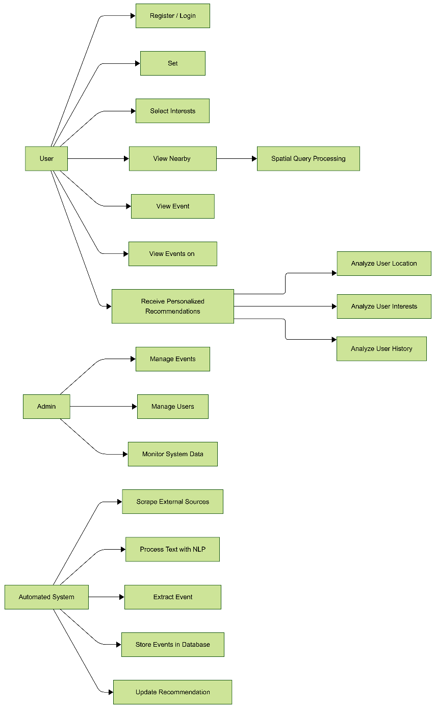

5.1.1. Explanation of the Use-Case Diagram

The Use Case diagram describes the functionality of the Event Recommendation System. This helps to establish the interactions between the main actors (User, Admin) and the secondary actor (Automated System).

The system has been designed to scrape event information from third-party sites, carry out Natural Language Processing, and deliver targeted recommendations based on user interests, location, and past interactions. The User plays the role of the main user of the application, who gets to access the application’s functionality of registration, editing, and interest account creation for personalization. Additionally, the Admin plays the role of the user who handles the operational aspect, taking care of event administration and user account administration for system integrity. Lastly, the Automated System refers to the system’s backend processes, which are handled using the Automated System’s ability to scrape event information, perform text analysis, and update the database.

The functionality primarily revolves around the event recommendation part, where the system brings together the user’s location analysis, interest matching, and past interaction analysis for event recommendation.

5.1.1.1. Main Scenario

The main scenario represents the standard flow in which the user would receive event recommendations personalized for them. The process starts when the User successfully logs into the system and updates their profile preferences by selecting specific interests they like, for example, technology or music. Following the configuration, the User requests the recommendation(s) via the system interface. As per this request, the system would then make use of the recommendation engine, requesting it to fetch the user’s present location, filter events based on selected interest tags, and compare them with the interaction history. Once the analysis has been processed, the system would then provide the user with a list of events to attend.

5.1.1.2. Sub Scenario
The first sub-scenario describes the Automated Data Acquisition process, which is self-contained and does not require any interaction. This process starts as the Automated System invokes a scheduled task for acquiring web data. The system retrieves the unrefined text information and processes the information through an NLP engine to comprehend the meaning. The important information of date, time, and location is derived from the text information. If the information is authenticated as being full, the system will save the new event in the database along with invoking a recommendation engine update to keep the repository updated.
The second sub-scenario corresponds to the View Nearby Events functionality concerning spatial query processing. Moreover, in this operation, the "Select View Nearby Events" option is selected by the User, which encourages them to allow the system to have access to its GPS. After receiving the authorization, the system executes a spatial query to identify how close the user is to the closest events. The closest events will be delivered to the User in case they exist, otherwise, the system will respond with an indication that there are no events close by.

5.2. Class Diagram
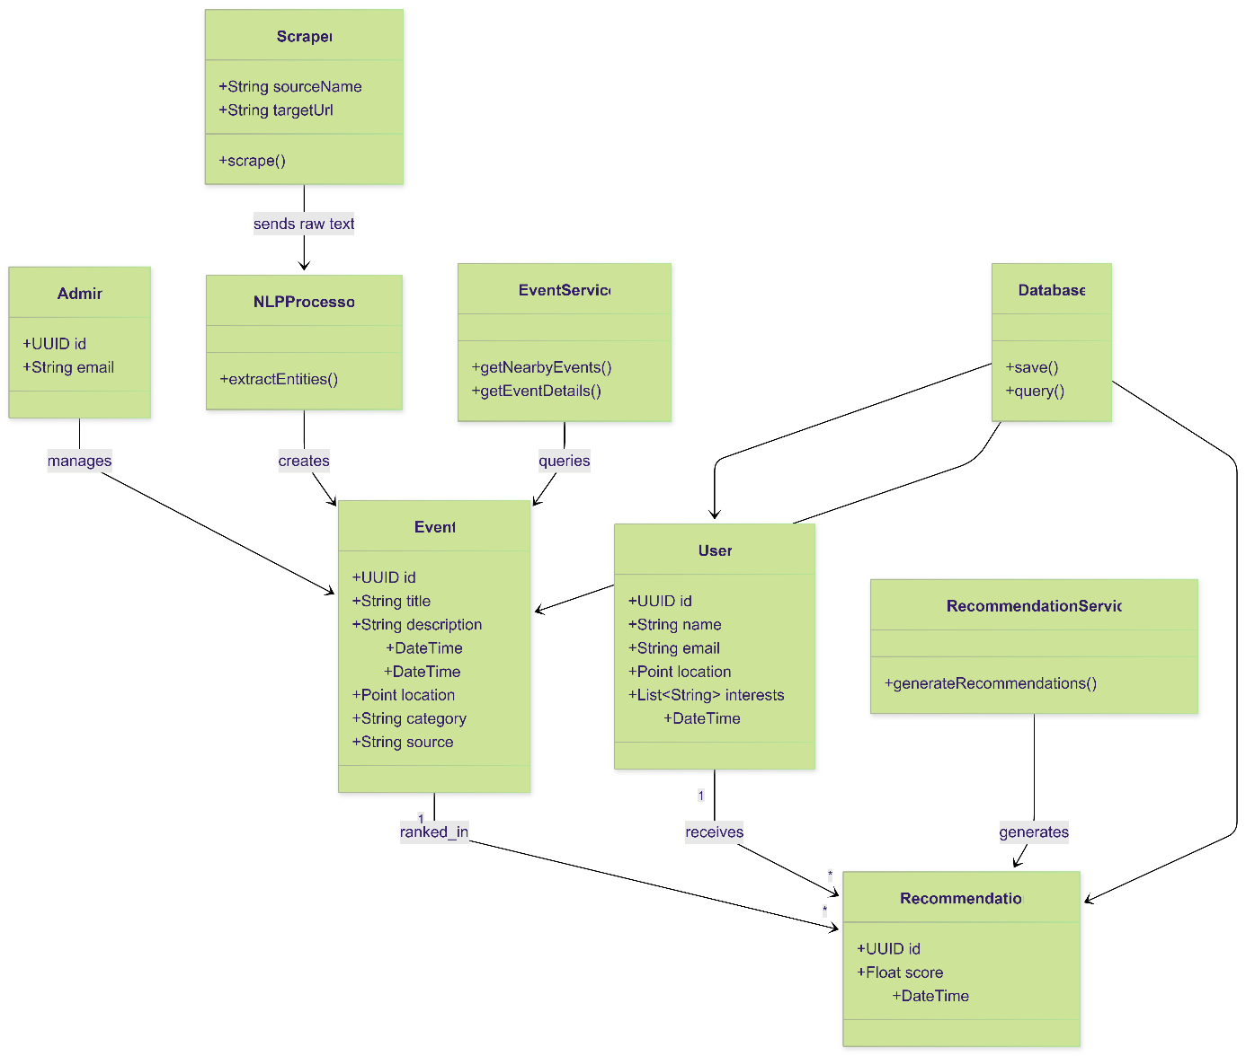

5.2.1. Explanation of the Class Diagram
The Class Diagram gives a static structural perspective of the Event Recommendation System. The Class Diagram strictly follows the principles of Object-Oriented Design. This includes breaking the Event Recommendation System into separate tiers that include data models (User, Event), service-offering classes (Scraper, RecommendationService), and data storage managers (Database).
The system architecture is modular in nature. This implies that the processing, extraction, and interface tasks are handled by various classes. Service and Processing classes:
The Scraper class begins the data extraction chain. This class accesses the remote web resources defined in the sourceName and targetUrl attributes. The class calls the scrape() method, which extracts raw text. The raw text is then passed to the extractEntities() method in the NLPProcessor class. The main objective is to tokenize unstructured text, getting key information of a significant EVENT, essentially RAW data to STRUCTURED EVENT data. Second, the system has the EventService class, acting as a bridge between the data acquisition. This class has methods like getNearbyEvents(), for geographical location of the EVENT, and getEventDetails(), for end-user informative details. RecommendationService is the heart of the analysis engine encompassing the generateRecommendations() method, processing user data to provide personalized suggestions.
Data Entities and Actors The core entity within the system is Event, which holds information about an event in general. Event holds properties such as the unique id with uuid, name, description, DateTime, and particular category details. The location details with attribute Point become important factors, which allow it to be queried based on spatial locations. The User class holds details about the users who interact with the system. The class includes details about personal identifiers with id as uuid, name, and email. To allow the recommendation mechanism, it holds details about user’s interests and location. The Admin class holds details about the admin who has the right to control the entire system. The right to control is indicated by the relationship where Admin oversees Event.
The Recommendation Model and Relationships The Recommendation class is the associate entity that connects the User class and the Event class together. This class holds the result of the recommendation algorithm process, whereby a calculated float value is stored, indicating the relevance of an event for a particular user. These relationships shown above demonstrate how these three classes are able to interact. The User class does have a relationship indicated as "receives" with one to many multiplicity, thereby indicating that a user receives several recommendations. The third class, however, Event, does have a relationship indicated as "ranked_in," thereby showing that several lists are able to comprise an event, as an event contains several lists. Lastly, there is the Database class, which serves as the persistence framework for the application context. The Database class does have dependencies on User class, Event class, and Recommendation class, whereby the save and query methods are applicable for the integrity of data within the application.

5.3. Activity Diagram
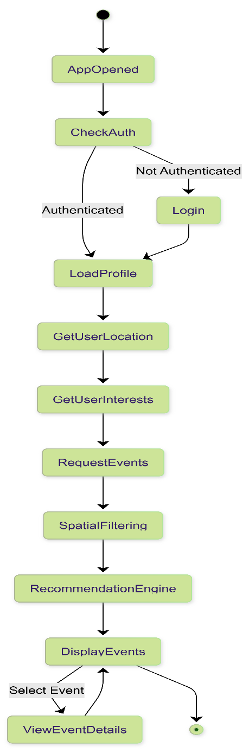

5.3.1. Explanation of the Activity Diagram
The Activity Diagram is used to graphically illustrate the dynamic process of the Event Recommendation System from the point of application startup until the final interaction with the user. The diagram describes the control flow between distinct states of the system, paying close attention to decisions like authentications as well as loops that occur during the viewing of events. The central purpose of this diagram is to illustrate how the linear processing of user information, particularly location and interests, occurs in order to form recommendations, in addition to dealing with conditional branching for security and user interaction.
The workflow begins at the start node upon the launching of the application, entering the AppOpened state. The first decision immediately follows, named CheckAuth, checking the authentication status of the user. If they are not logged in, the path branches off to the Login activity, requiring them to be logged in before moving further. If they already have been logged in, they bypass the login screen altogether. Then, both paths meet at the LoadProfile state, attempting to load the identity as well as preferences of the user. Aggregating data sequentially, after loading the profile, the GetUserLocation and GetUserInterests activities take place, as the next activity, RequestEvents, needs to be filled with context-driven data.
Once the initiation of the event request has been made, the SpatialFiltering operation removes any events that do not fall within the geographical range of the user’s activities. The filtered results are then processed by the RecommendationEngine for a relevance score, after which the results are shown to the customer in DisplayEvents. This cycle illustrates the interaction between the customer, as shown by the diagram, such that if the customer makes a 'Select Event' interaction, the system moves to the ViewEventDetails stage. Following the viewing process, the cycle goes back to DisplayEvents, enabling customers to continue searching for alternatives endlessly until they leave the page, thereby completing the process at the final node, indicating the end of the customer interaction process.

5.4. Sequence Diagram
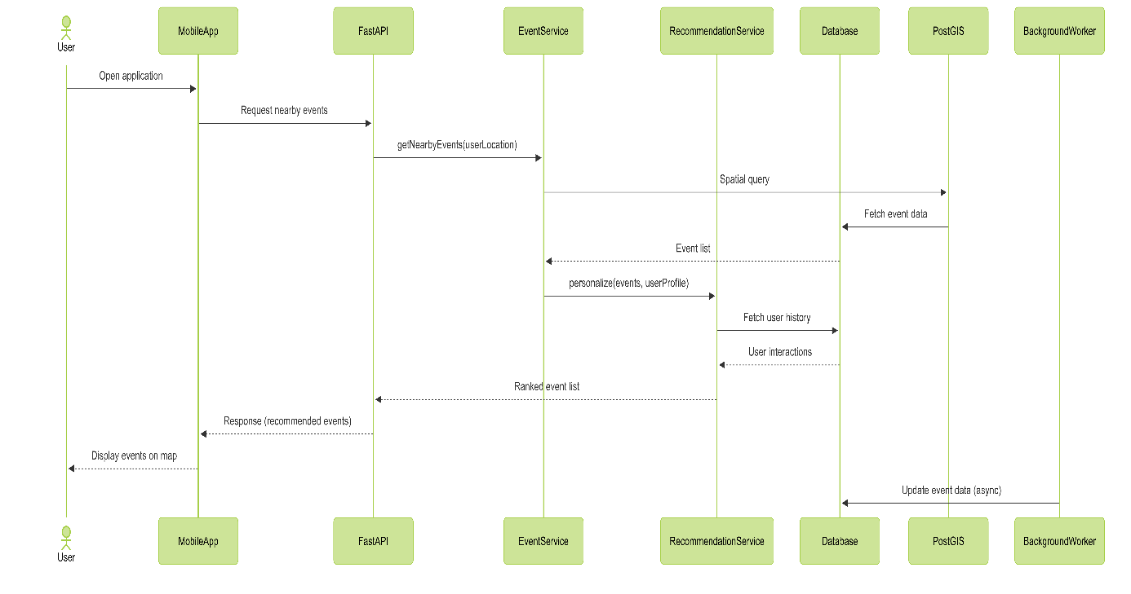

5.4.1. Explanation of the Sequence Diagram
The Sequence Diagram above shows the order of message exchange and runtime interaction between the architectural elements of the system during the process of event recommendation. The interaction begins where the User opens the application, and this triggers the Mobile App to send a request to the FastAPI application interface for nearby events. The FastAPI ends up receiving this request and subsequently calls the EventService by triggering the method 'getNearbyEvents' with location information from the user. A very important interaction follows where the EventService calls the PostGIS module to perform a customized spatial query that efficiently returns the raw list of events that lie geographically within the user's location radius.The raw list of events, along with the user profile, is then passed to the RecommendationService by the EventService module in order to perform logic on user personalization.The RecommendationService then talks to the central Database to retrieve the user's historical interactions so that it can weight and rank the events against past preferences. It returns the processed and ranked event list back to the EventService and, subsequently, back down through the FastAPI layer to the MobileApp, which renders the finalized recommendations on to the map for the User. It also shows a decoupled asynchronous operation whereby a BackgroundWorker is independently updating event data in the Database in a way that ensures that processes related to data ingestion do not block the real-time experience of the user.

5.5. Database Diagram
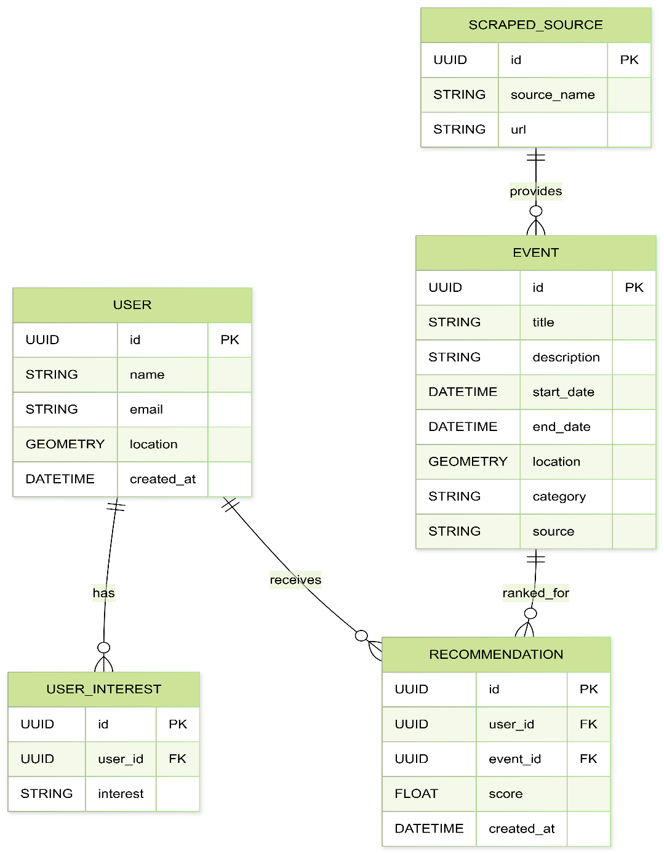

5.5.1. Explanation of the Database Diagram
A database diagram is provided that is a graphical representation of the database structure for the Event Recommendation System. The system design is based on the User table, which contains basic account information, including the location field defined in Geometry type, which supports efficient spatial querying through PostGIS. In order for the database design to be normalized, user preferences have been separated in the User_Interest table through a one-to-many relationship called “has”, which permits multiple interest labels for multiple users without violating data consistency. The Event table is the main repository for activity information, which contains date information including the date of completion, in addition to location information critical for spatial calculations. Provenance data is explicitly modeled through the Scraped_Source table, while the relationship with events is modeled as a one-to-many relationship involving the Scraped_Source table. Lastly, the role of the Recommendation table is to provide an essential bridging entity to model the logical relationship between users and events and to provide an essential Foreign Key linking the table to the User and Event tables with a float attribute to model the calculated score for fast retrieval of the ranking results for users.

